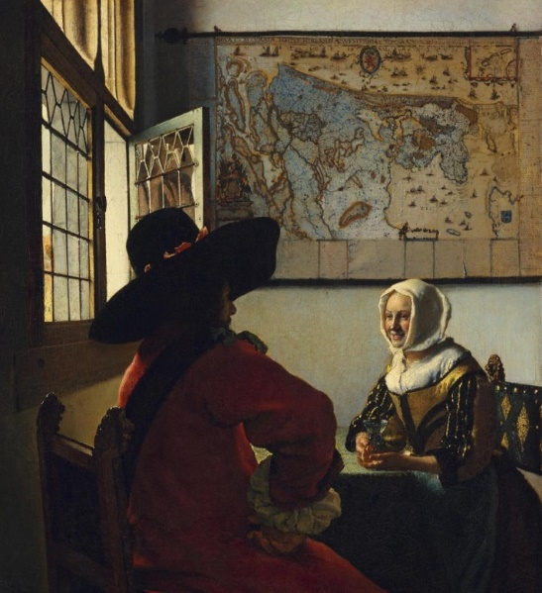

Vermeer: Officer and the Laughing GIrl, c. 1672.
Vermeer in New York
There are only thirty-six Vermeer paintings that have survived, and New York houses eight of them.
Aimee Ng, curator at the Frick, discusses (on Youtube) the three Vermeer paintings in the Frick Collection. We will also look at the five Vermeer paintings at the Metropolitan Museum of Art.
WEDNESDAY JULY 20TH 11 A.M - NOON

