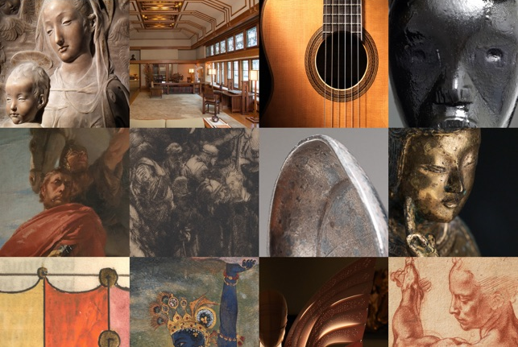
MATTITUCK – LAUREL LIBRARY
82nd & Fifth:
Masterpieces of the Metropolitan Museum of Art

Enjoy extraordinary works from the Metropolitan Museum of Art from the experts; 100 curators from across the Museum talk about 100 works of art that changed the way they see the world.

On the large screen in the Meeting Room downstairs.
Wednesdays, 11 a.m. to noon. August 3, 17, 24, 31.

