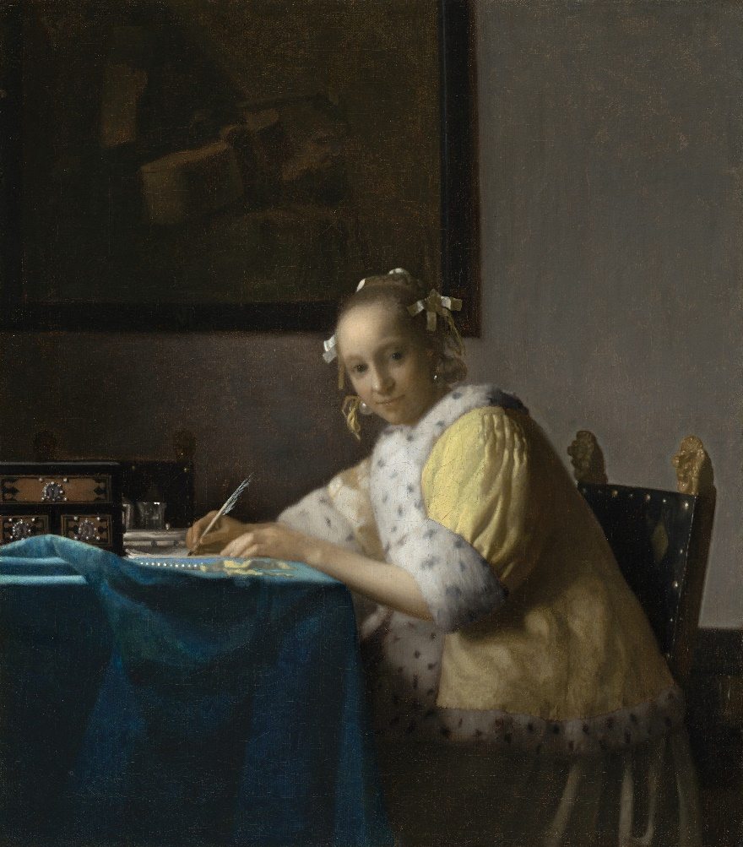

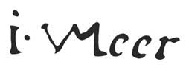

Vermeer: A Lady Writing, c. 1672.
Vermeer: Master of Light

Join us for this comprehensive appreciation of the art of Vermeer. Discover the “secrets” of his technique, his meticulous attention to lighting and composition. Through the power of technology, this film takes the viewer beneath the surface of the paintings to unveil captivating insights into the master’s work. Narrated by Meryl Streep.

WEDNESDAY JULY 13TH 11 A.M - NOON

